Code

🌟 Definition
# Source: AI Source: Provided by: [Data Path: Persons Table -> ID Column: 1, Name_En Column: Motasem Essam] -> From: [ChatGPT] on [6/7/2026]
Code is a set of instructions written in a programming language that tells a computer what actions to perform.
It is the foundation of all software, websites, mobile apps, games, operating systems, and databases.

🎯 Simple Definition
# Source: AI Source: Provided by: [Data Path: Persons Table -> ID Column: 1, Name_En Column: Motasem Essam] -> From: [ChatGPT] on [6/7/2026]
Code = Instructions Written for a Computer
Just as humans follow recipes, computers follow code.

🧠 Real-World Analogy
# Source: AI Source: Provided by: [Data Path: Persons Table -> ID Column: 1, Name_En Column: Motasem Essam] -> From: [ChatGPT] on [6/7/2026]
Imagine giving instructions to a chef.
Recipe
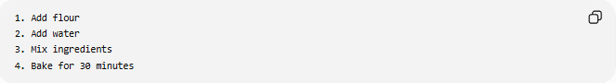
1. Add flour
2. Add water
3. Mix ingredients
4. Bake for 30 minutes
The chef follows the instructions.

Code
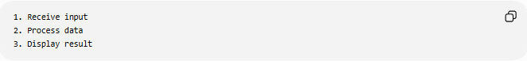
1. Receive input
2. Process data
3. Display result
The computer follows the instructions.

🔄 How Code Works
# Source: AI Source: Provided by: [Data Path: Persons Table -> ID Column: 1, Name_En Column: Motasem Essam] -> From: [ChatGPT] on [6/7/2026]
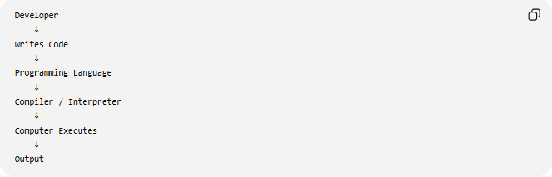
Developer
↓
Writes Code
↓
Programming Language
↓
Compiler / Interpreter
↓
Computer Executes
↓
Output

📚 Example of Code
# Source: AI Source: Provided by: [Data Path: Persons Table -> ID Column: 1, Name_En Column: Motasem Essam] -> From: [ChatGPT] on [6/7/2026]
PHP
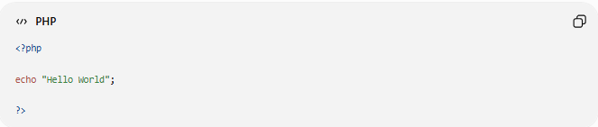
<?php
echo "Hello World";
?>
Output:
Hello World

Python
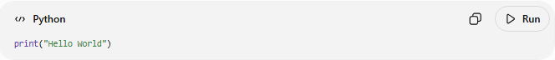
print("Hello World")
Output:
Hello World

JavaScript
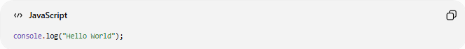
console.log("Hello World");
Output:
Hello World

🧩 Components of Code

1️⃣ Variables
# Source: AI Source: Provided by: [Data Path: Persons Table -> ID Column: 1, Name_En Column: Motasem Essam] -> From: [ChatGPT] on [6/7/2026]
Store data.
Example:
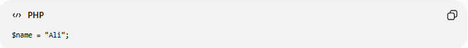
$name = "Ali";

2️⃣ Functions
# Source: AI Source: Provided by: [Data Path: Persons Table -> ID Column: 1, Name_En Column: Motasem Essam] -> From: [ChatGPT] on [6/7/2026]
Reusable blocks of code.
Example:
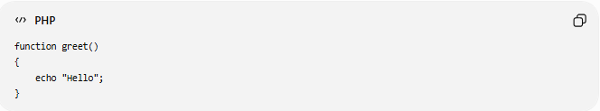
function greet()
{
echo "Hello";
}

3️⃣ Conditions
# Source: AI Source: Provided by: [Data Path: Persons Table -> ID Column: 1, Name_En Column: Motasem Essam] -> From: [ChatGPT] on [6/7/2026]
Make decisions.
Example:
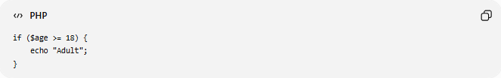
if ($age >= 18) {
echo "Adult";
}

4️⃣ Loops
# Source: AI Source: Provided by: [Data Path: Persons Table -> ID Column: 1, Name_En Column: Motasem Essam] -> From: [ChatGPT] on [6/7/2026]
Repeat actions.
Example:
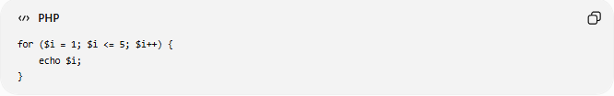
for ($i = 1; $i <= 5; $i++) {
echo $i;
}

5️⃣ Classes
# Source: AI Source: Provided by: [Data Path: Persons Table -> ID Column: 1, Name_En Column: Motasem Essam] -> From: [ChatGPT] on [6/7/2026]
Blueprints for objects.
Example:
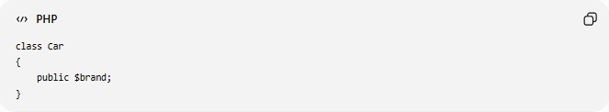
class Car
{
public $brand;
}

📂 Types of Code
# Source: AI Source: Provided by: [Data Path: Persons Table -> ID Column: 1, Name_En Column: Motasem Essam] -> From: [ChatGPT] on [6/7/2026]

Source Code
Code written by developers.
Example:
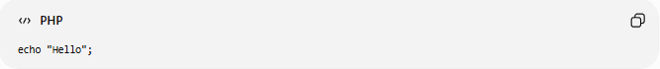
echo "Hello";

Machine Code
Binary instructions executed directly by the CPU.
Example:
10101010 00110011

Bytecode
Intermediate code used by some languages.
Examples:
- Java Bytecode
- Python Bytecode

🌍 Where Code Is Used
# Source: AI Source: Provided by: [Data Path: Persons Table -> ID Column: 1, Name_En Column: Motasem Essam] -> From: [ChatGPT] on [6/7/2026]
Websites
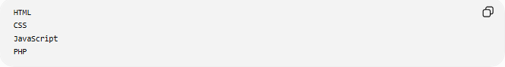
HTML
CSS
JavaScript
PHP

Mobile Apps
Android → Kotlin / Java
iPhone → Swift

Desktop Applications
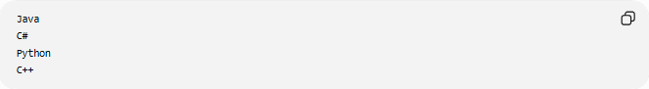
Java
C#
Python
C++

Databases
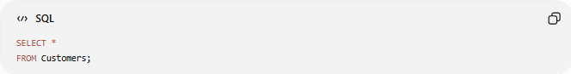
SQL Code:
SELECT *
FROM Customers;

Artificial Intelligence
Python Example:
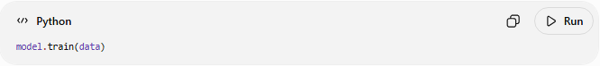
model.train(data)

📊 Code vs Program vs Software
# Source: AI Source: Provided by: [Data Path: Persons Table -> ID Column: 1, Name_En Column: Motasem Essam] -> From: [ChatGPT] on [6/7/2026]
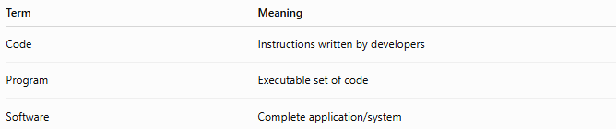
Term | Meaning
Code | Instructions written by developers
Program | Executable set of code
Software | Complete application/system

Relationship
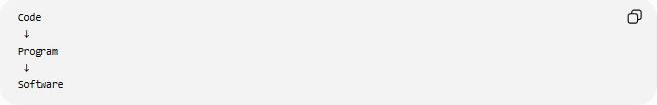
Code
↓
Program
↓
Software

📊 Code vs Script
# Source: AI Source: Provided by: [Data Path: Persons Table -> ID Column: 1, Name_En Column: Motasem Essam] -> From: [ChatGPT] on [6/7/2026]
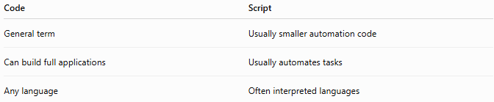
Code | Script
General term | Usually smaller automation code
Can build full applications | Usually automates tasks
Any language | Often interpreted languages

Example Script:
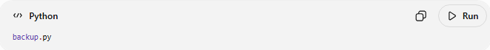
backup.py
Automates file backups.

🛠️ Common Programming Languages for Writing Code
# Source: AI Source: Provided by: [Data Path: Persons Table -> ID Column: 1, Name_En Column: Motasem Essam] -> From: [ChatGPT] on [6/7/2026]
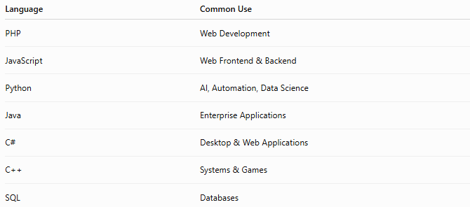
Language | Common Use
PHP | Web Development
JavaScript | Web Frontend & Backend
Python | AI, Automation, Data Science
Java | Enterprise Applications
C# | Desktop & Web Applications
C++ | Systems & Games
SQL | Databases

📋 Characteristics of Good Code
# Source: AI Source: Provided by: [Data Path: Persons Table -> ID Column: 1, Name_En Column: Motasem Essam] -> From: [ChatGPT] on [6/7/2026]
✅ Readable
✅ Maintainable
✅ Efficient
✅ Secure
✅ Reusable
✅ Well Documented

Good Example
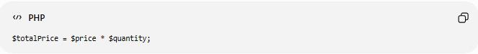
$totalPrice = $price * $quantity;

Poor Example
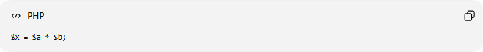
$x = $a * $b;
The first example is easier to understand.

🧠 Simple Analogy
# Source: AI Source: Provided by: [Data Path: Persons Table -> ID Column: 1, Name_En Column: Motasem Essam] -> From: [ChatGPT] on [6/7/2026]
Think of a computer as a worker.
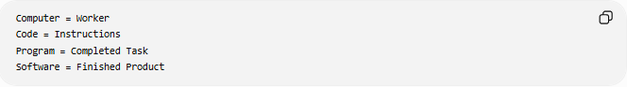
Computer = Worker
Code = Instructions
Program = Completed Task
Software = Finished Product
Without instructions, the worker cannot perform any task.

🧭 Summary
# Source: AI Source: Provided by: [Data Path: Persons Table -> ID Column: 1, Name_En Column: Motasem Essam] -> From: [ChatGPT] on [6/7/2026]
Code is a collection of instructions written in a programming language that tells a computer what to do. Developers write code to create applications, websites, databases, mobile apps, and other software systems. Code is the foundation of software development and is transformed into programs and complete software solutions that users interact with every day.

